1. Set Up The Environment

•Set up an AWS account if you do not have one, you should be able to set up a free account to use for the project.

•Python Environment: Ensure you have Python installed. Use virtual environments to manage dependencies.

•Install Required Libraries: Use pip, conda, etc to install necessary libraries.

**Steps:**

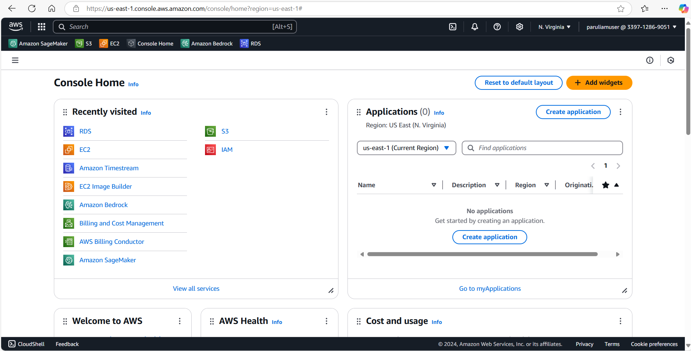

**Amazon Linux 2 AMI (HVM)**

**t2.micro**

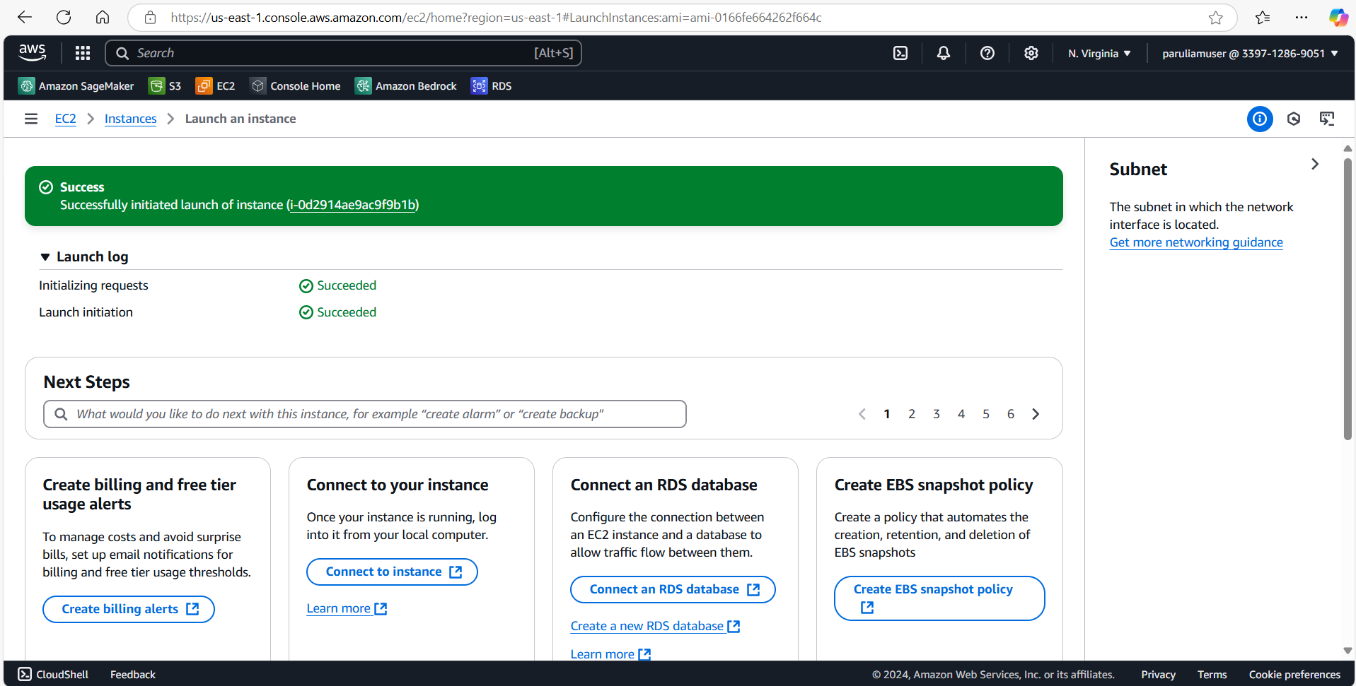

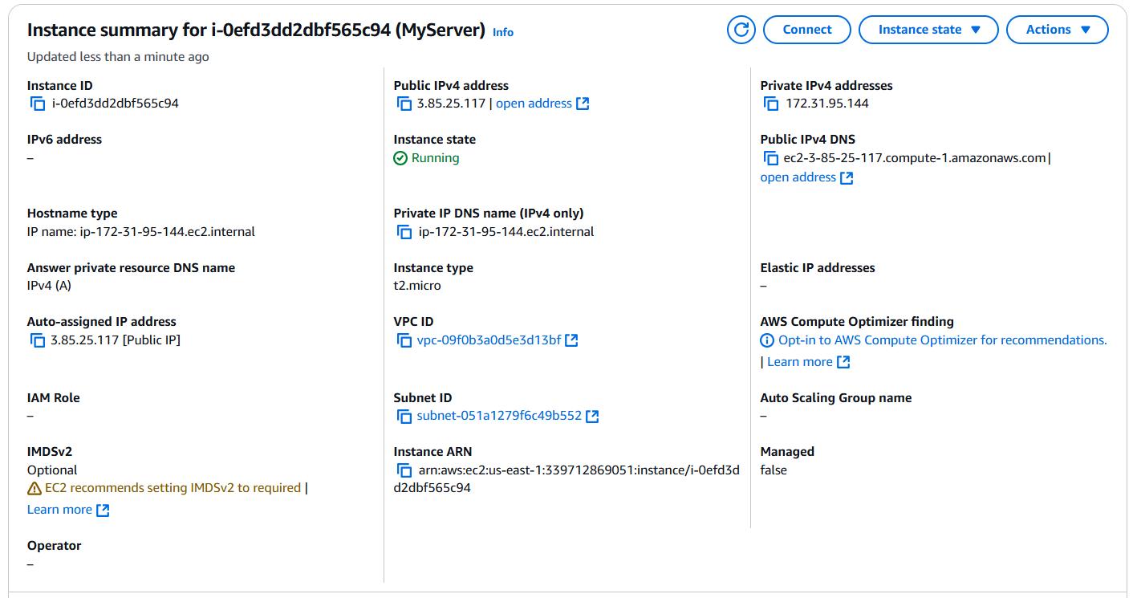

**Python environment set up:**

**Installed python3.8 and created a new venv with it**

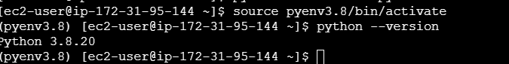

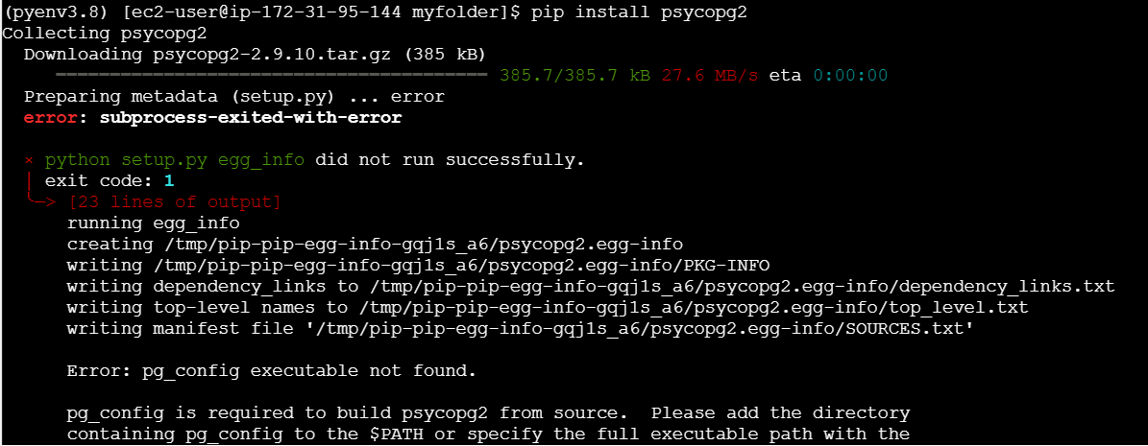

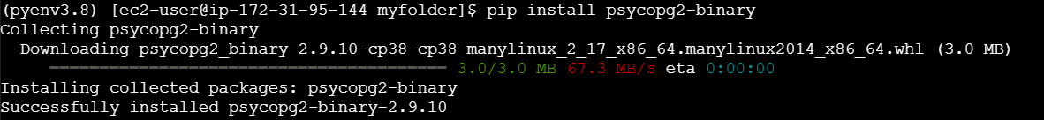

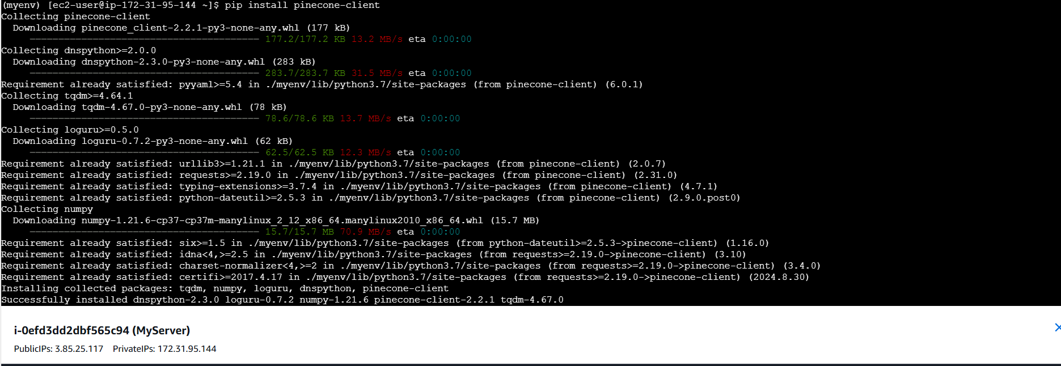

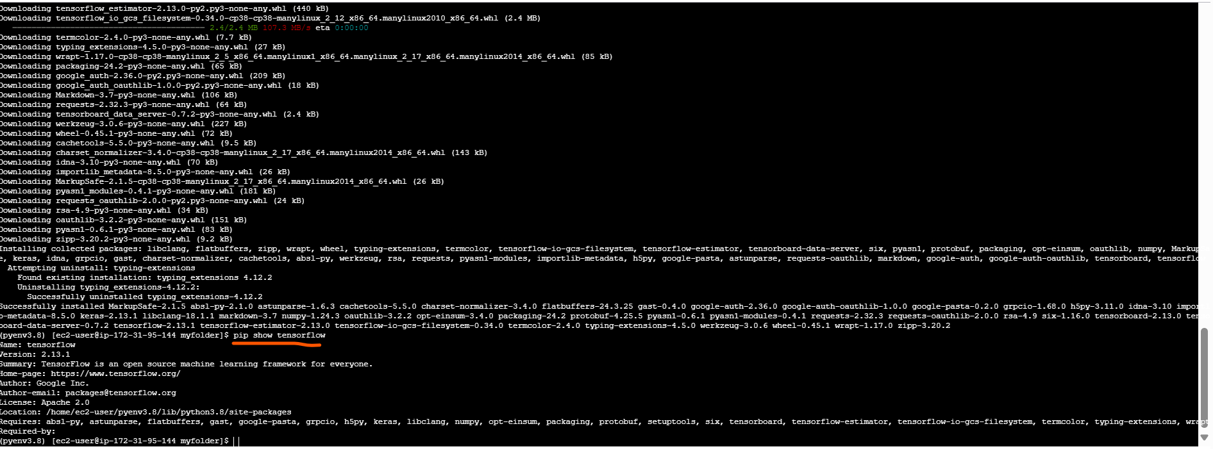

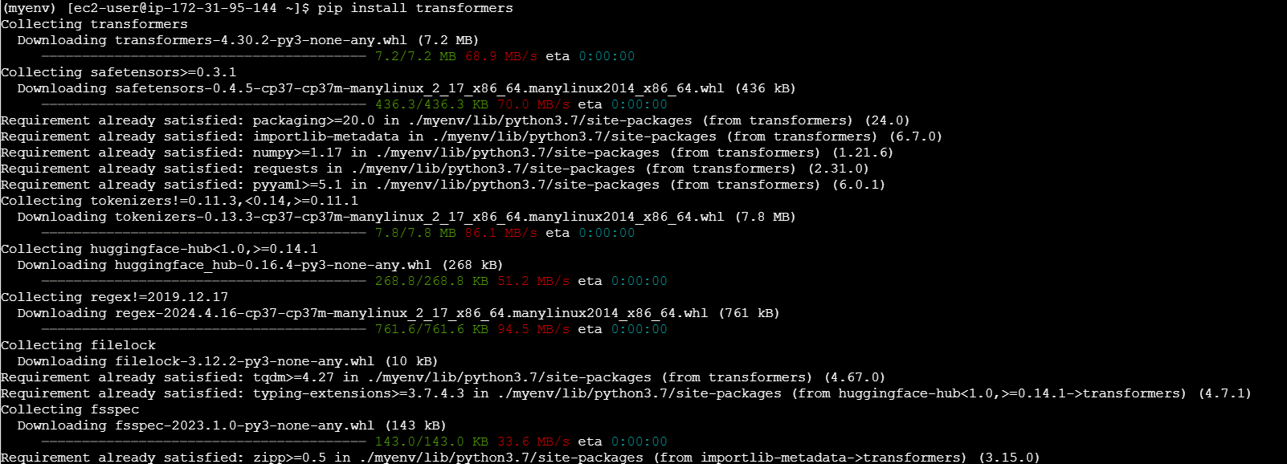

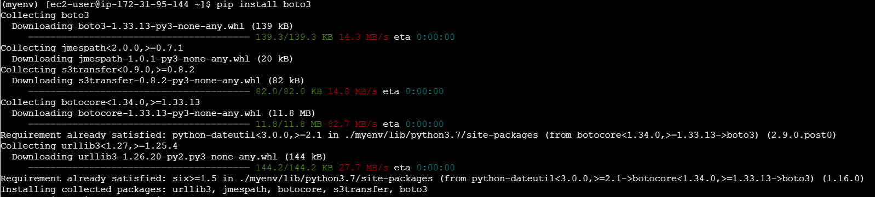

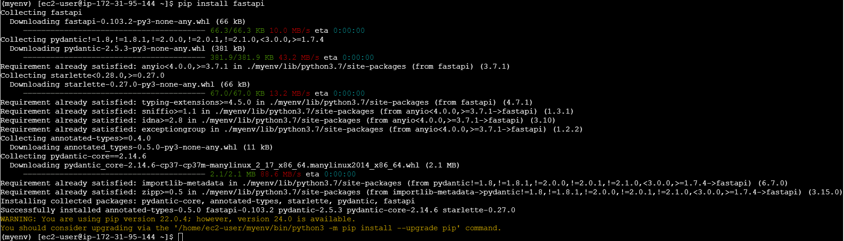

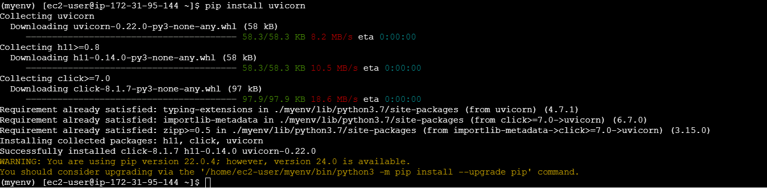



**2. Data Storage and Retrieval**

**• PostgreSQL: Use PostgreSQL to store your structured data.**

**• Setup PostgreSQL: Install and configure PostgreSQL.**

**• Create Tables: Define your schema and create tables.**

**• Load some sample data, this can be whatever makes sense.**

**Steps:**

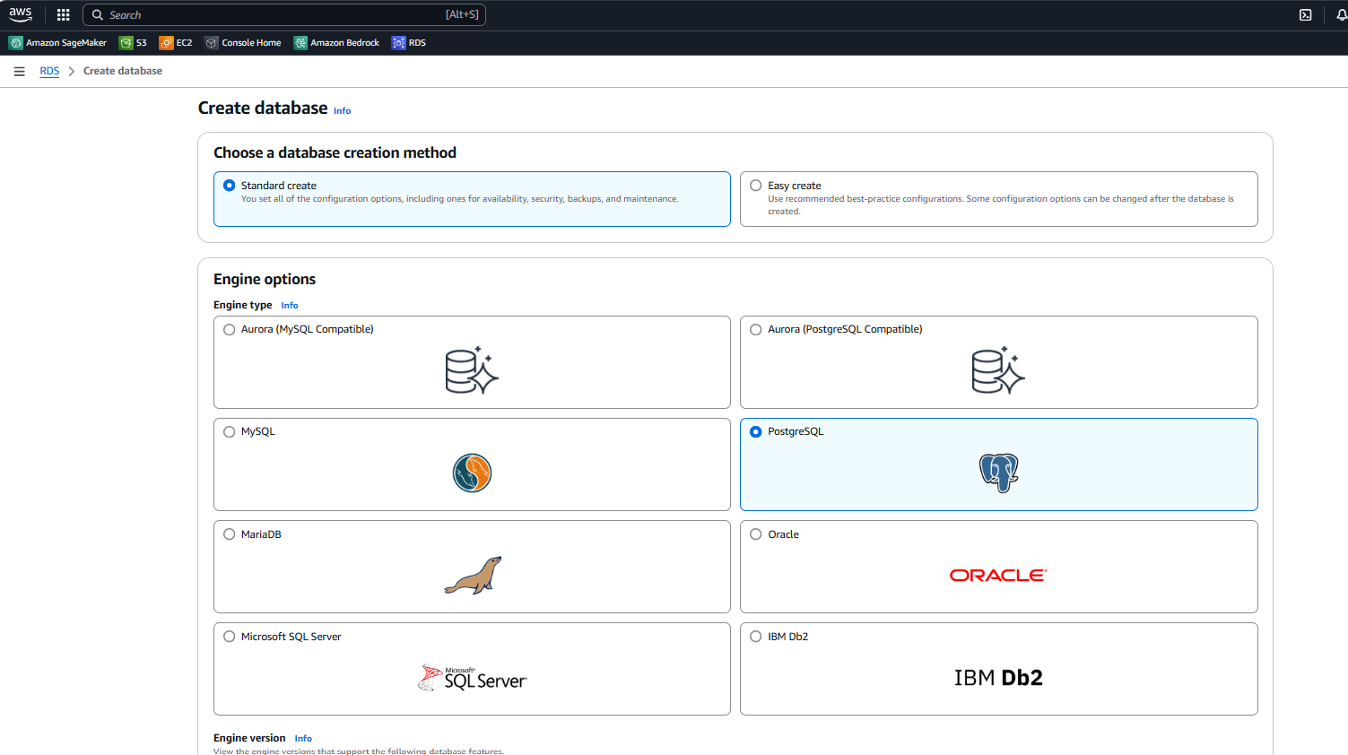

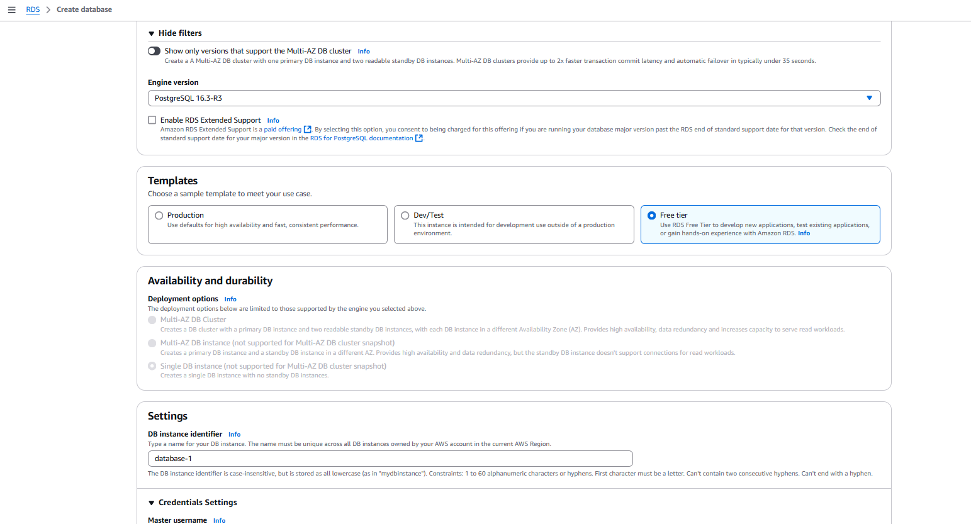

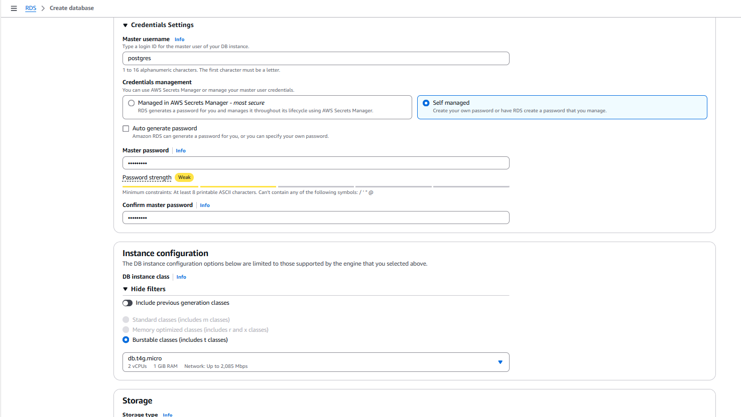

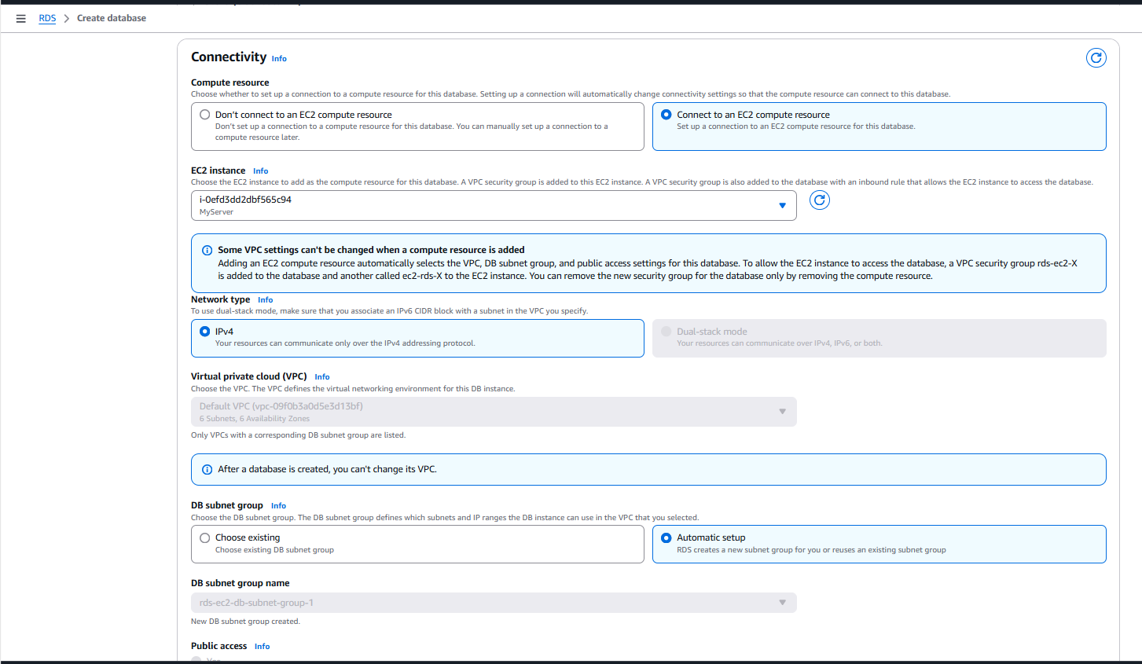

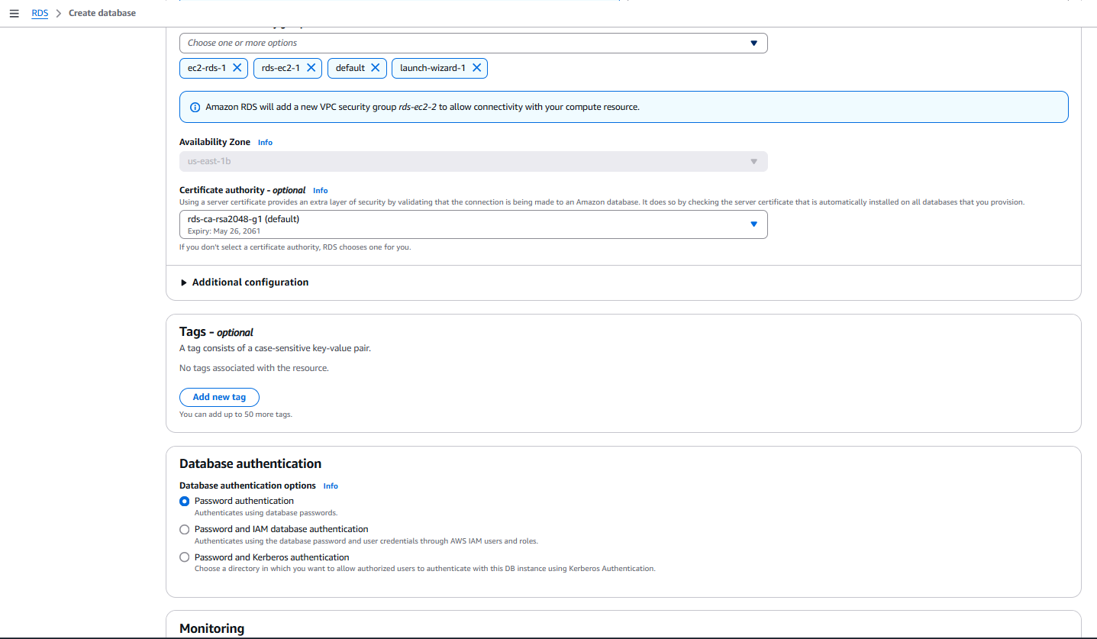

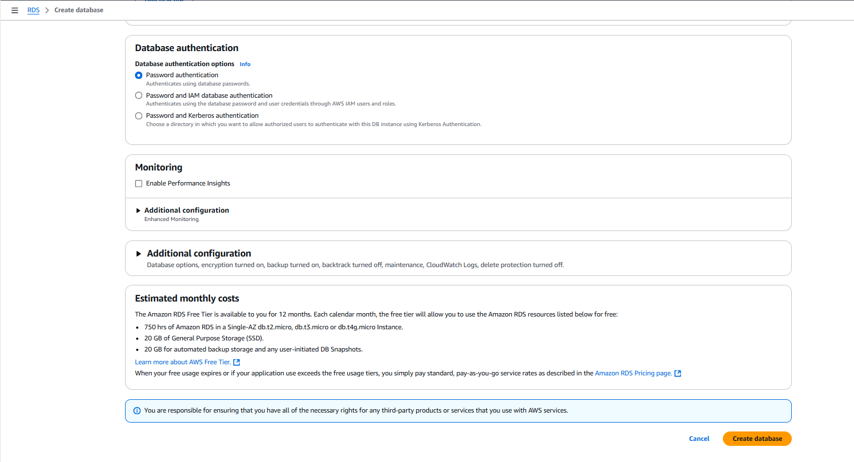

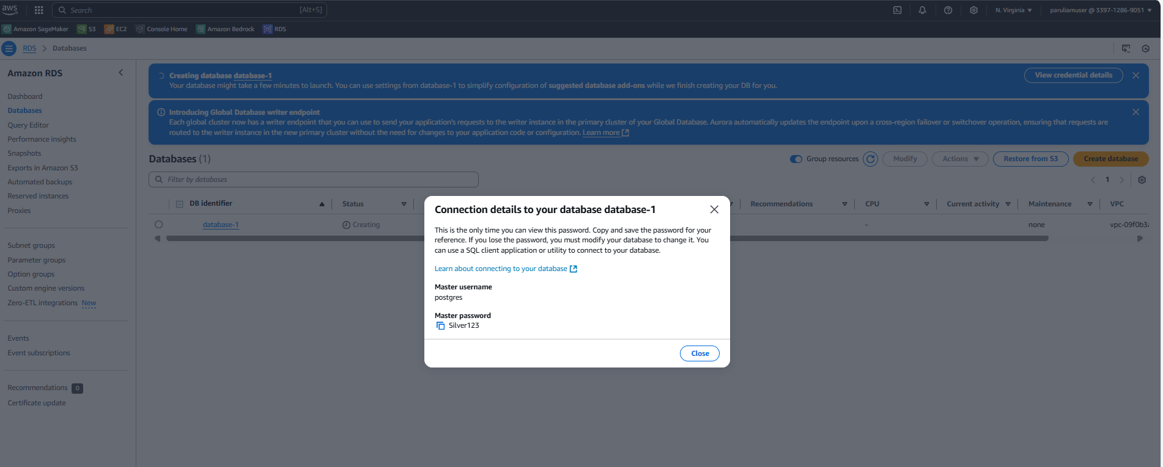

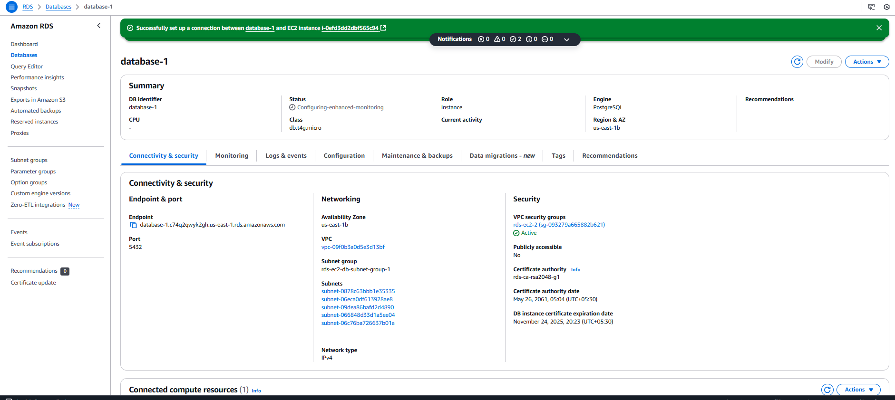

Trying to connect the db - postgres now:

psql -h database-1.c74q2qwyk2gh.us-east-1.rds.amazonaws.com -U postgres -d postgres -p 5432

password:

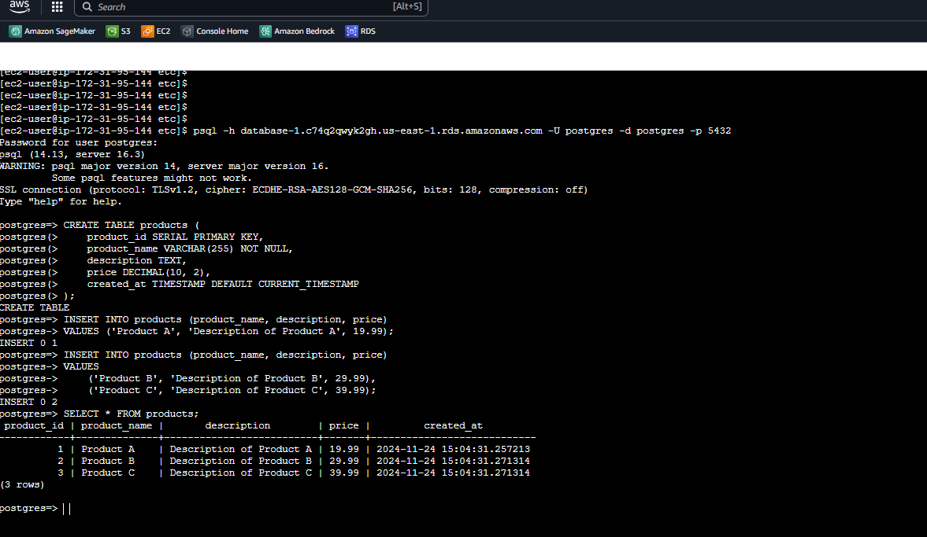

**3. Vector Storage with Pinecone.io**

**• Pinecone.io: Use Pinecone for vector storage and similarity search.**

**• Initialize Pinecone: Create an account and get your API key.**

**• Create Index: Initialize and create an index in Pinecone.**

**Steps:**

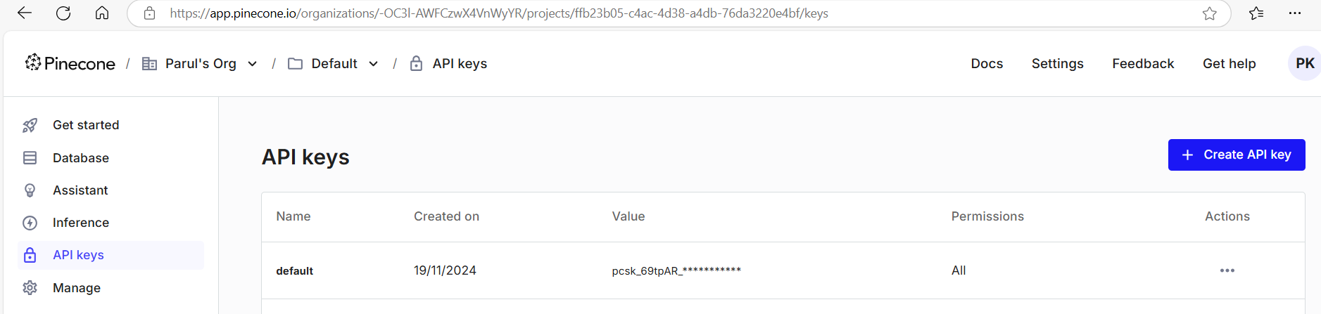

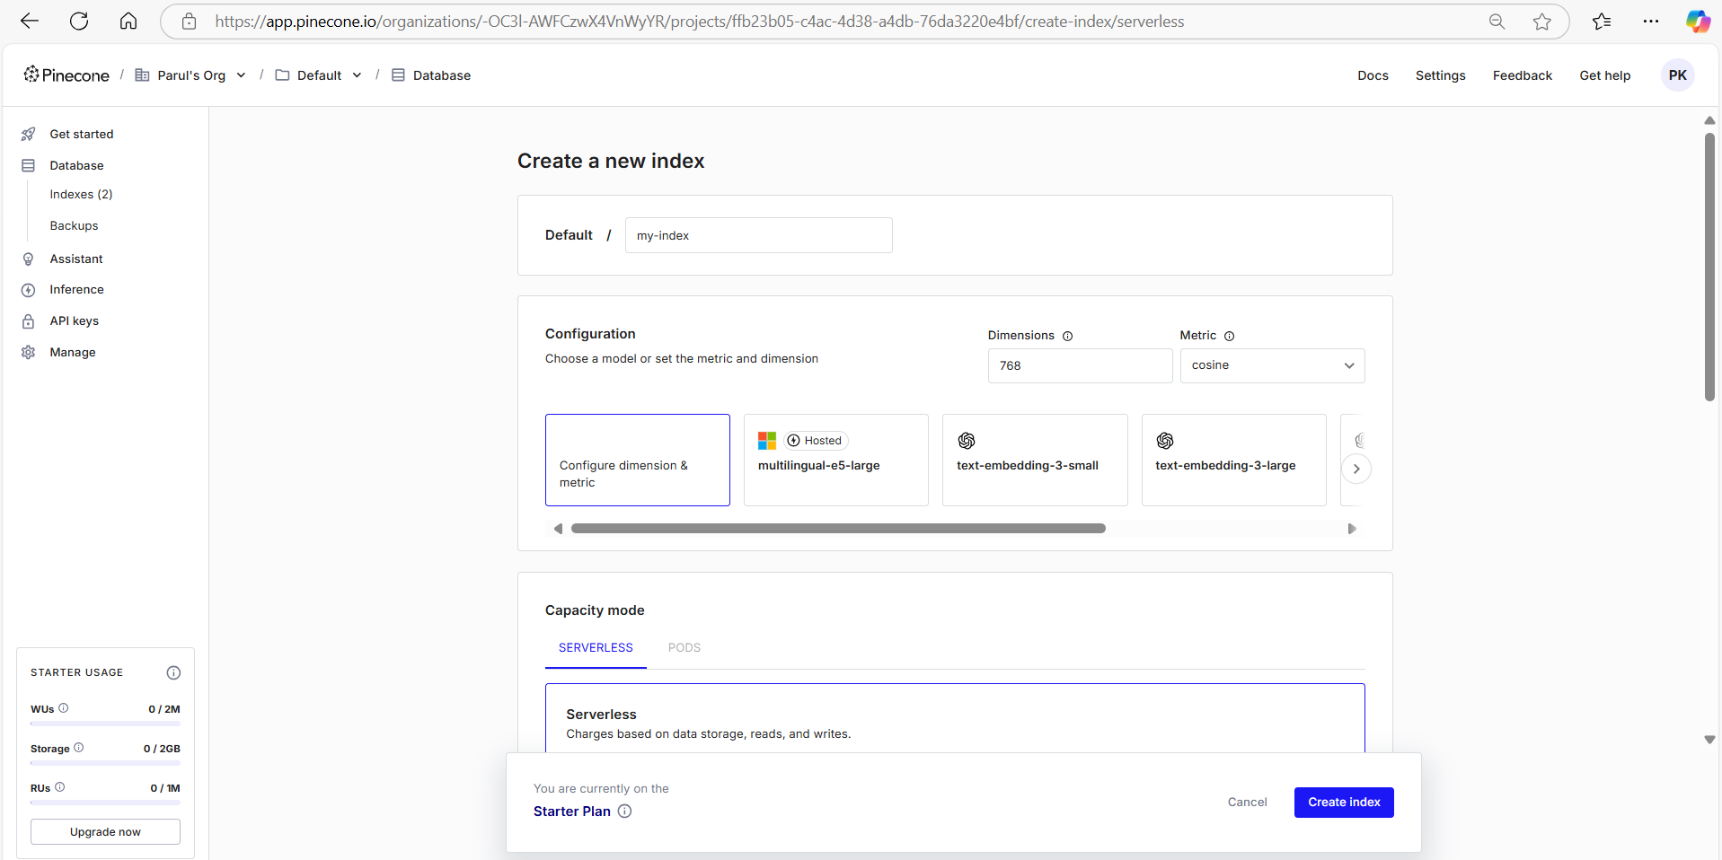

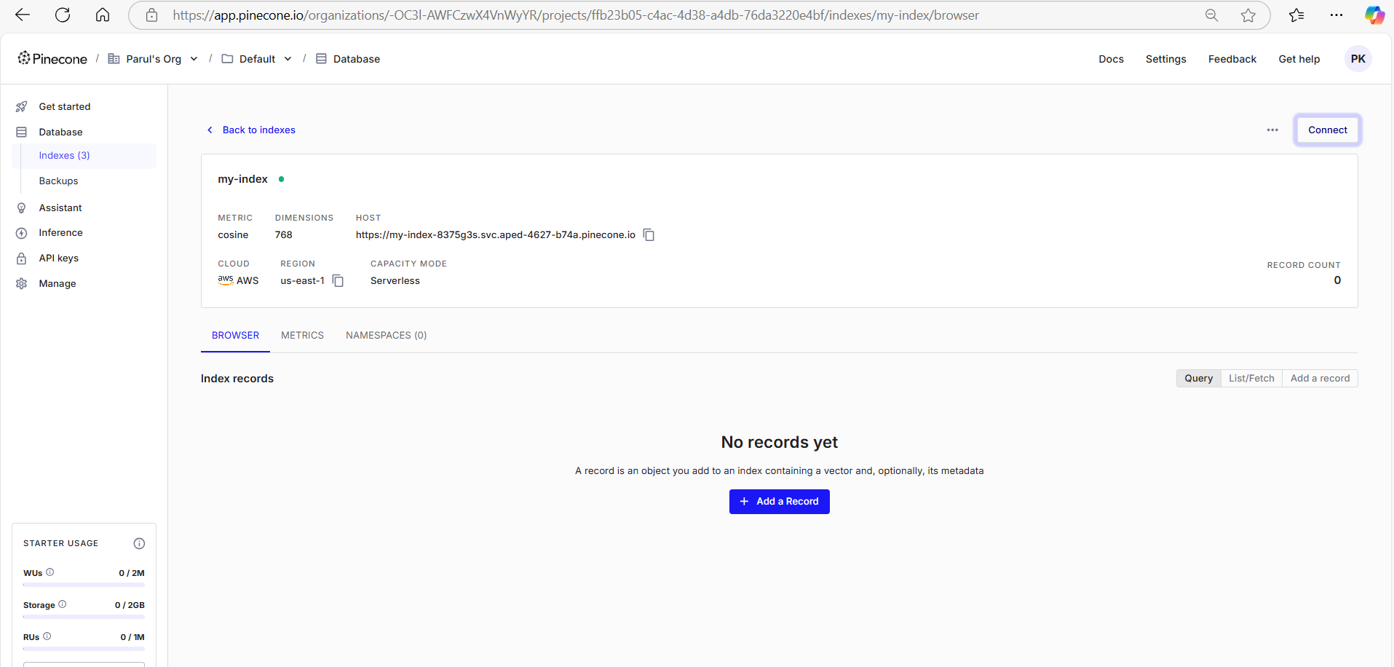

**4. Text Embedding with Hugging Face**

**• Hugging Face Model: Use a pre-trained model to convert text to embeddings**

**5. Data Ingestion**

**• Ingest Data: Extract data from PostgreSQL or a similar RDBMS, convert to embeddings, and store in Pinecone.**

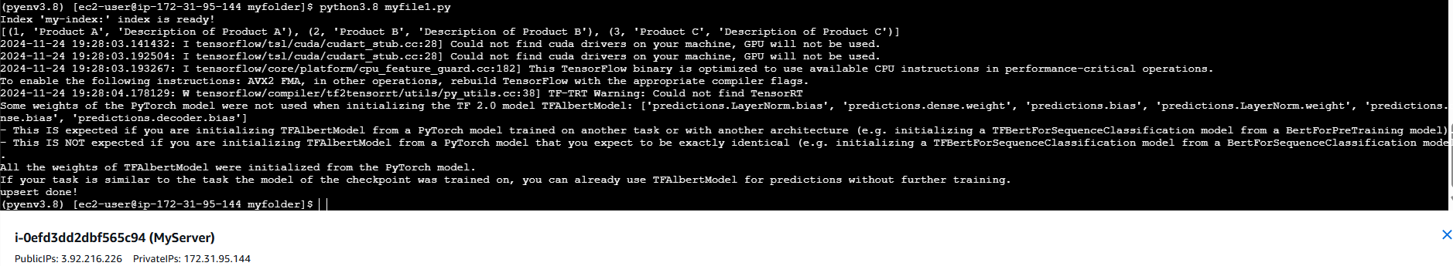

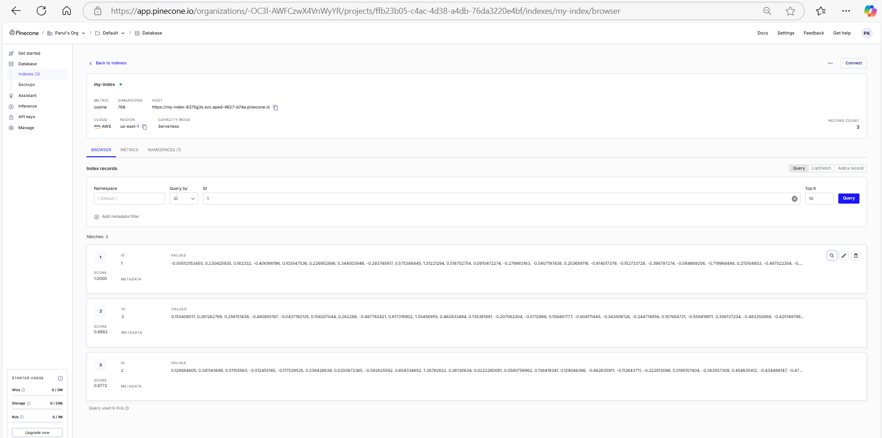

**6. Query Processing**

**• Query Embedding: Convert user queries to embeddings**

**7. AWS Bedrock Integration**

**• AWS Bedrock: Use AWS Bedrock for additional AI/ML services if needed.**

**• Setup AWS SDK: Configure AWS SDK for Python (Boto3).**

**8. Generate Final Results**

**• Combine Results: Use the retriever (Pinecone) and generator (Hugging Face model) to generate final search results.**

**9. Deployment**

**• Deploy: Deploy your application using a cloud service.**

**• API: Create an API to interact with your search engine.**



